8. Master Slave Architecture
Step 1: Create Agents/Slave

1.1 Make 2 folders as Agent1 and Agent2 in the directory.
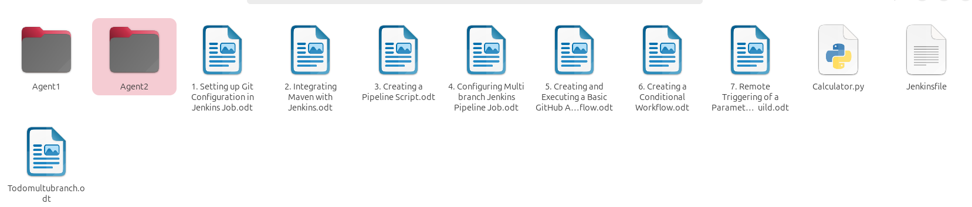

1.2 Click on the Manage Jenkins option as shown in the screenshot below → Click on the Nodes option as shown in the screenshot below.
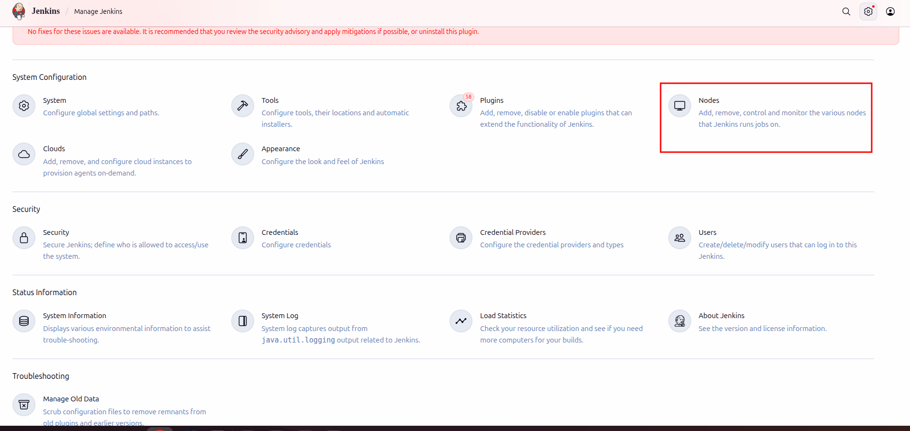

1.3 Click on New Node
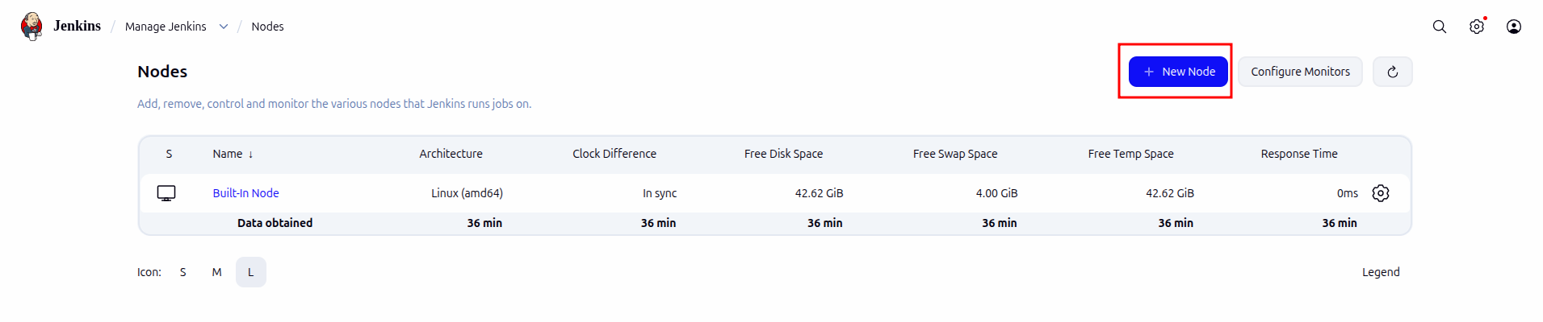

1.4 Enter the Node name as Agent1, select the Permanent Agent project option, and click on Create
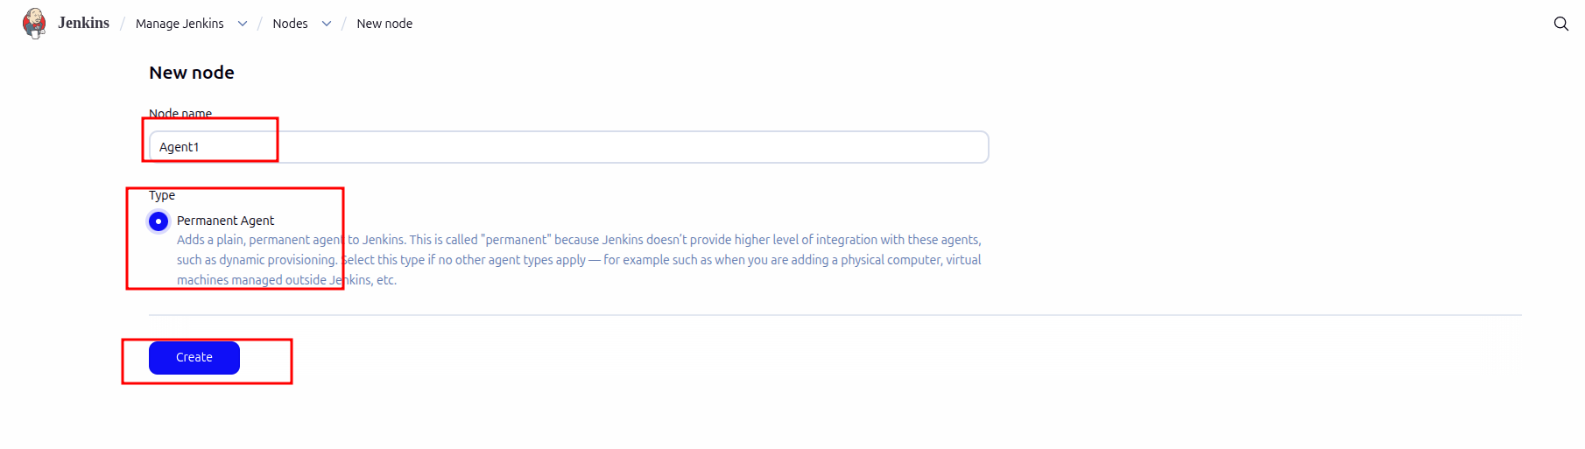

1.5 Add the path of Agent1 folder from directory.

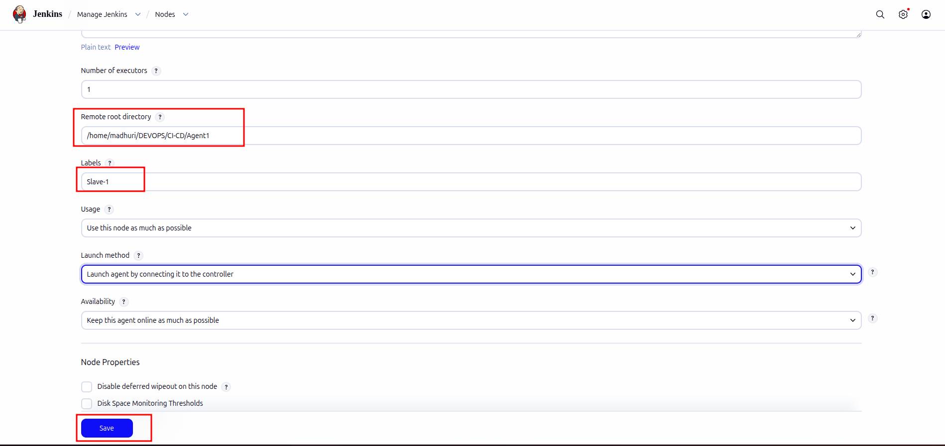
1.6 Similarly create Agent 2
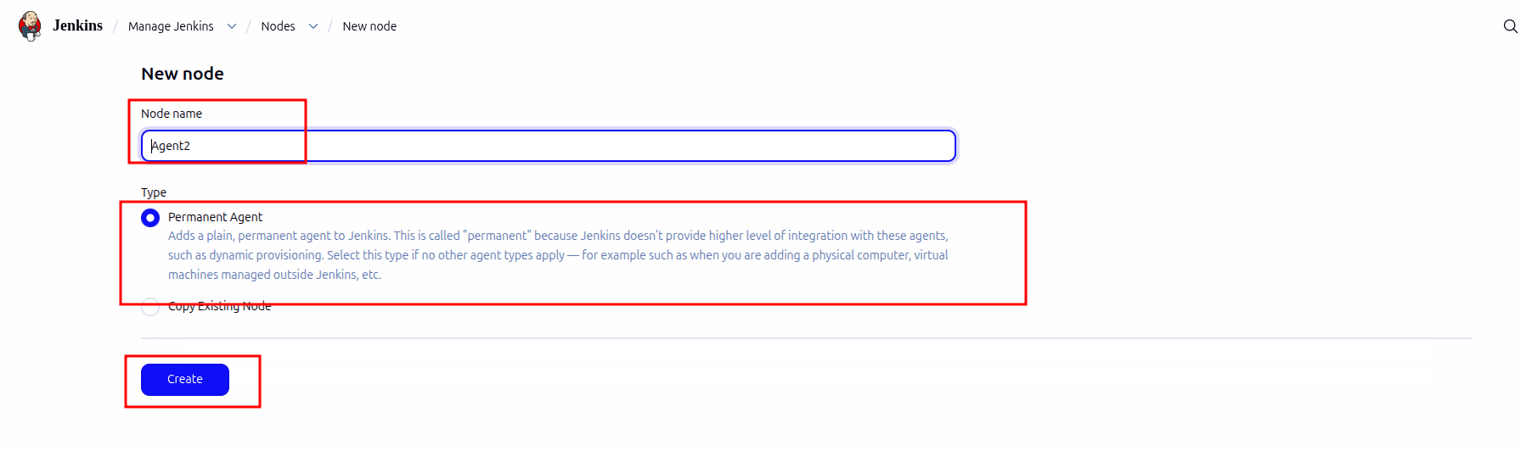
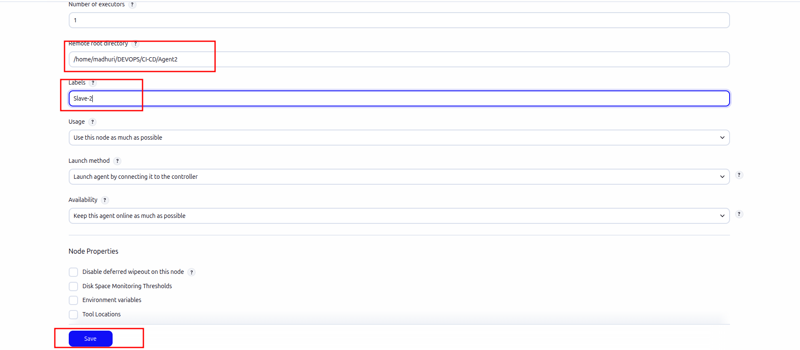

Step 2. Connect Agent to master node

2.1 Go to Manage Jenkins → Click on Agent1

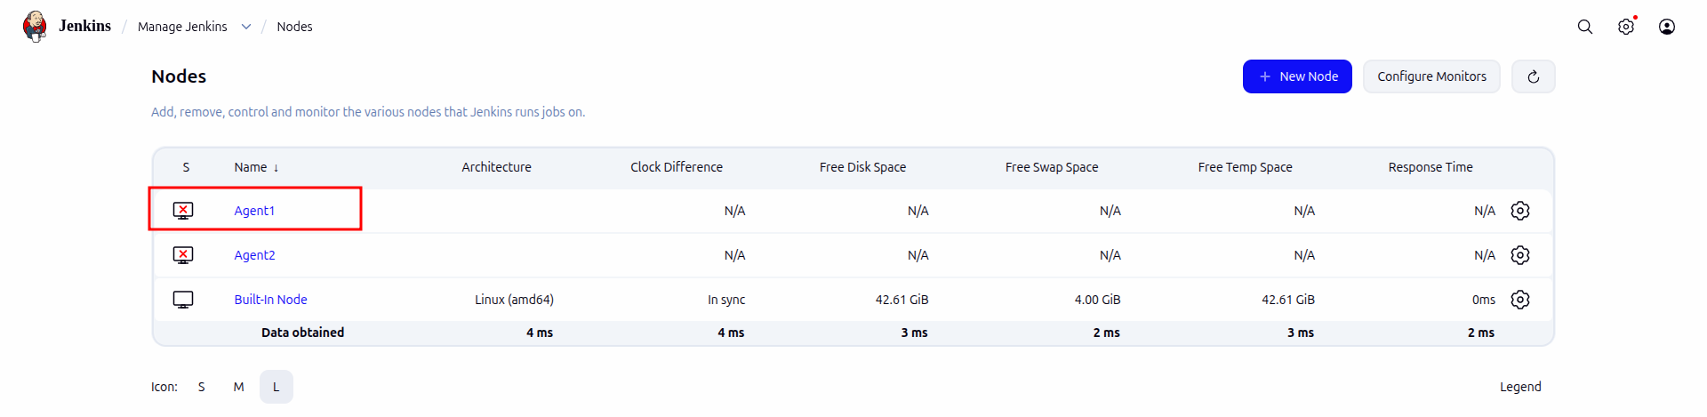

2.2 Copy the command → Run form agent command line for unix/linux

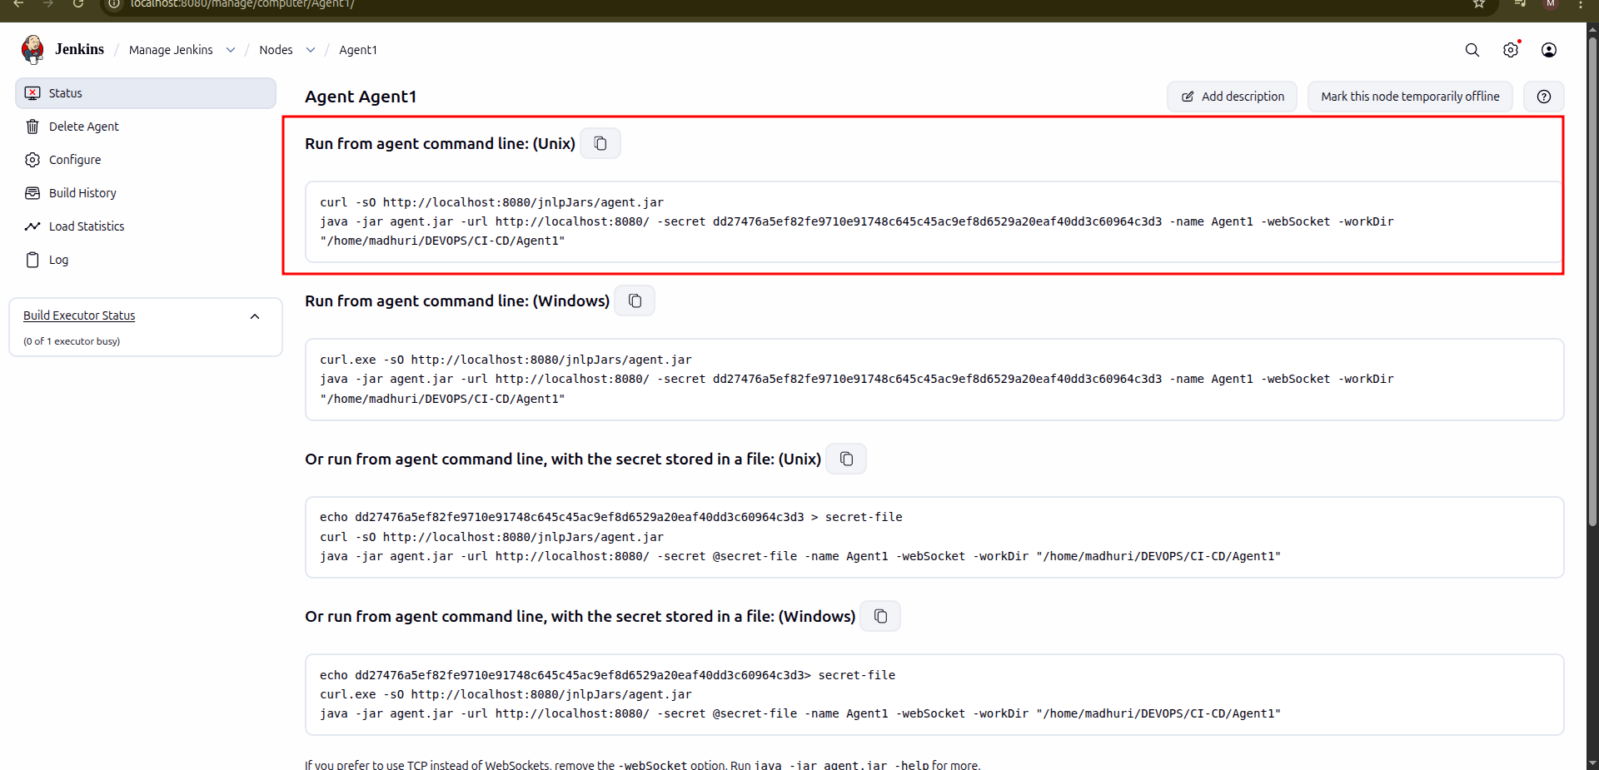

2.3 Go to folder Agent1 and open cmd/terminal And Run command

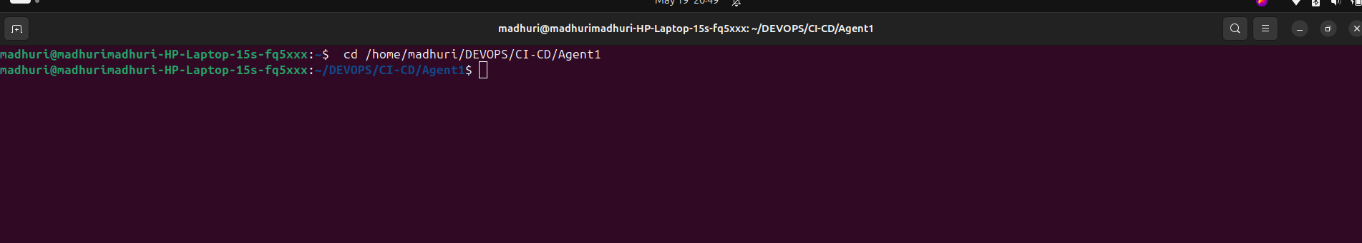

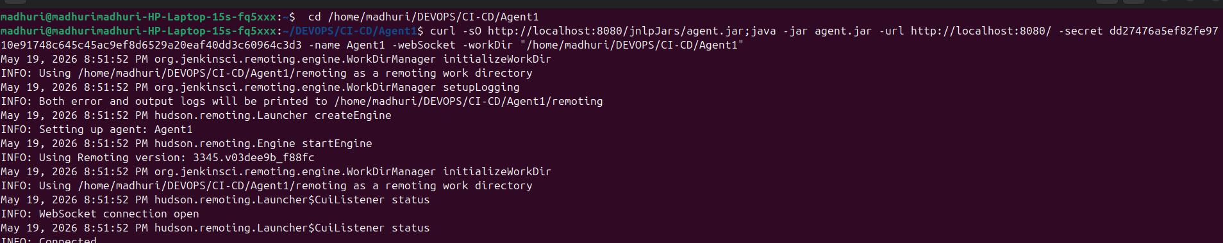

Note: Do not close the terminal and do not type ctrl + c

2.4 Similary with Agent2/ Slave 2 in new terminal

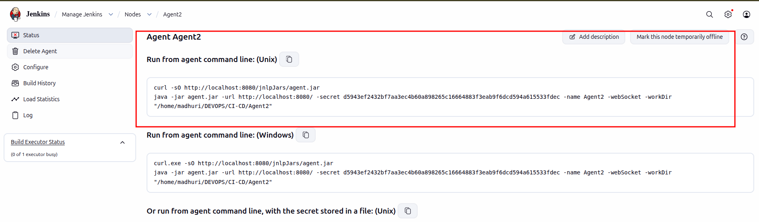

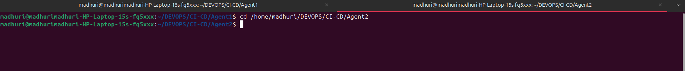

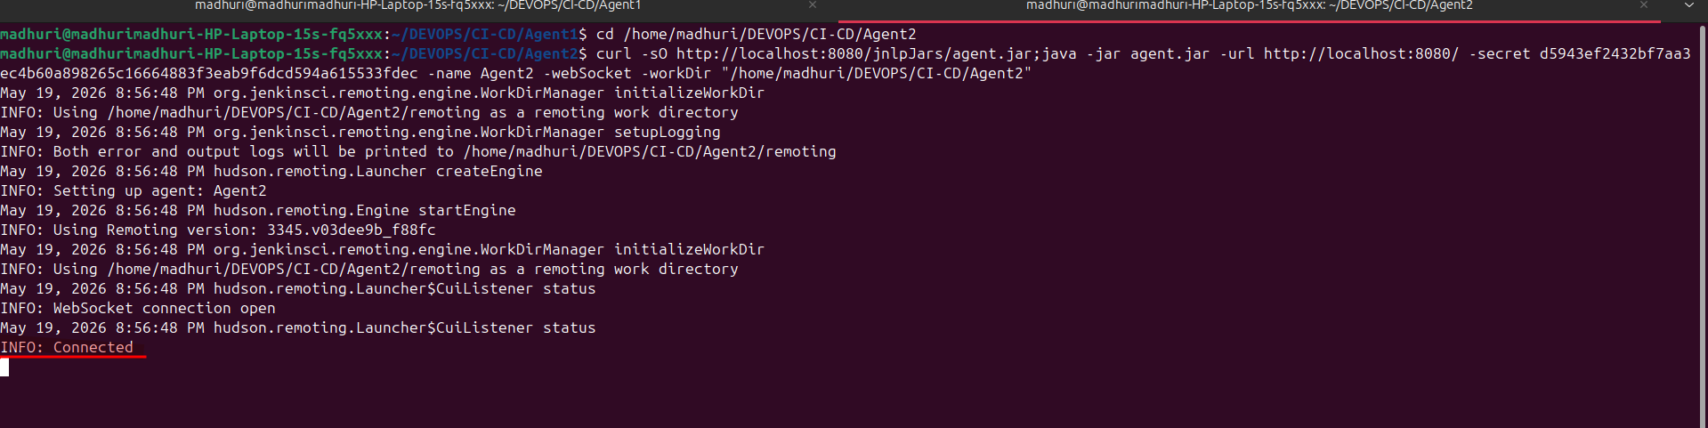

2.5 Now both the Agents are connected to master

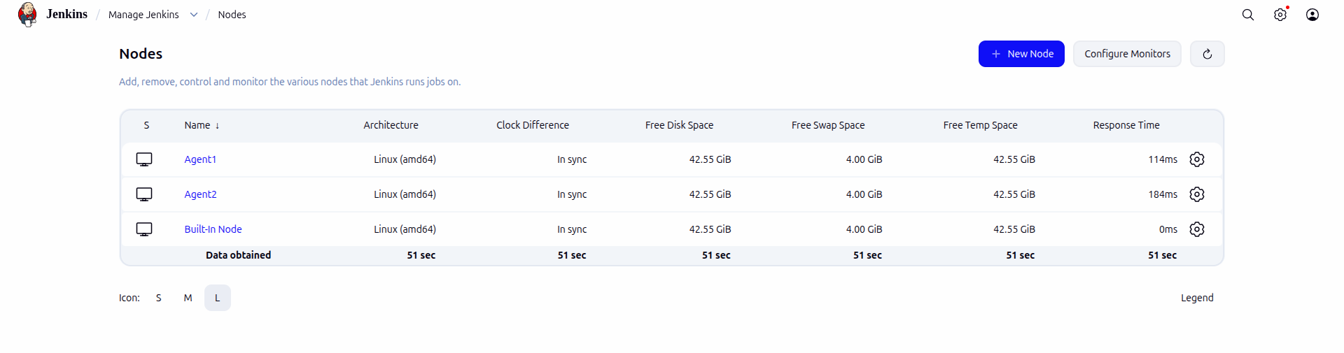

Step 3: Run jobs on Agent nodes

3.1 Go to New Item → Enter name as Agent1_Job1 → select Maven Project → Click Ok

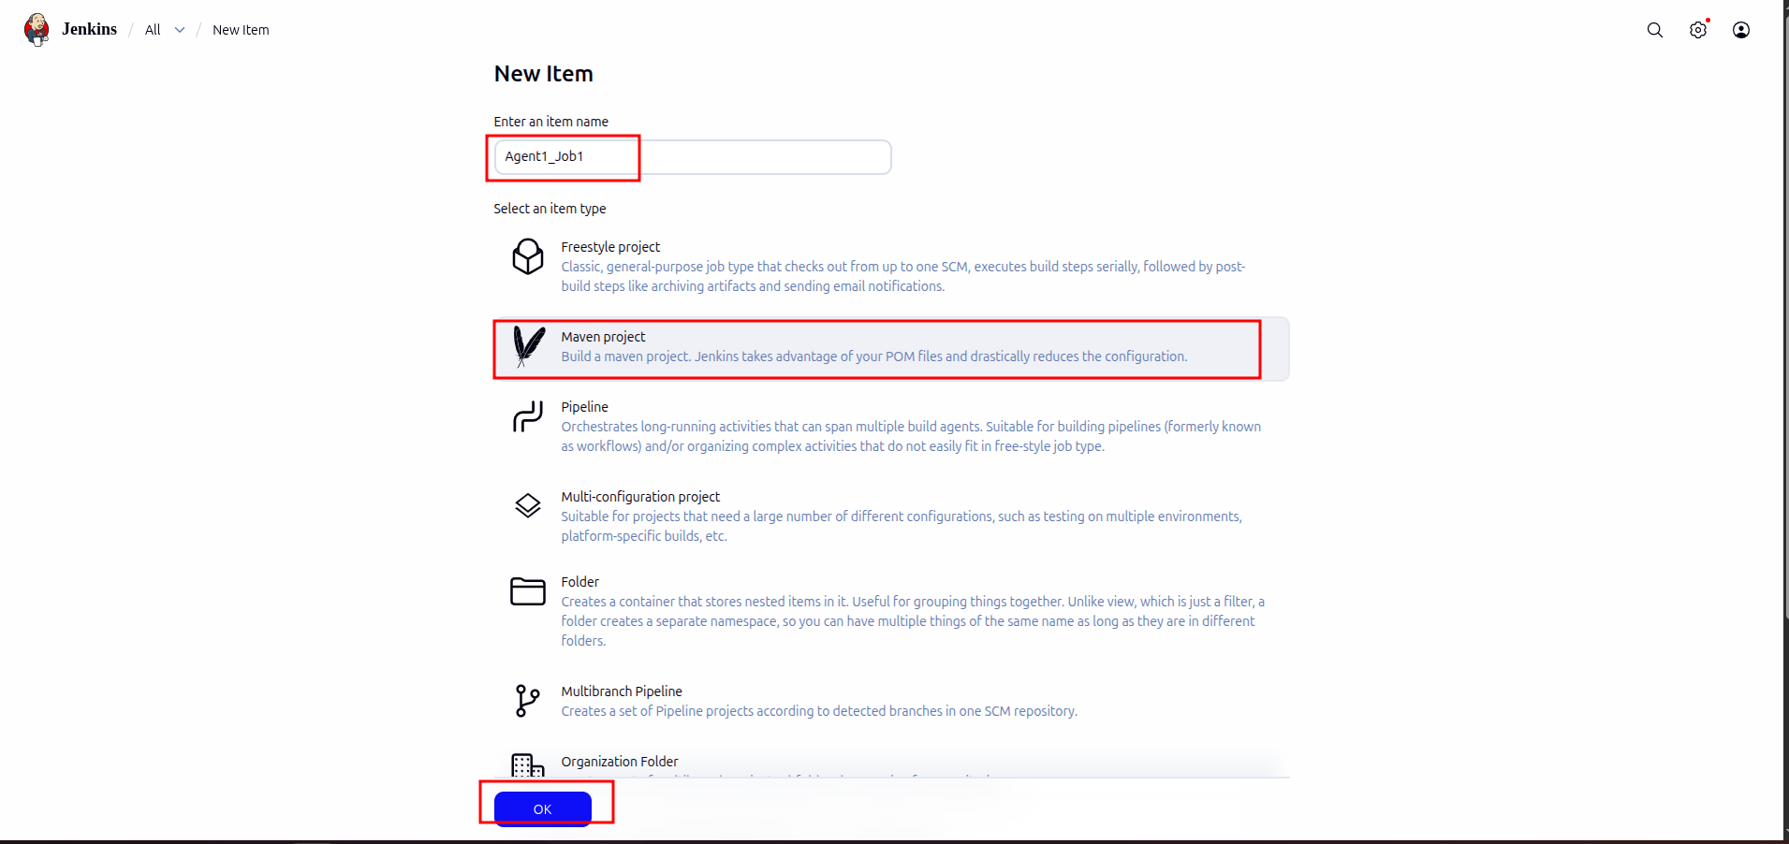

3.2 In repository URL paste Github URL → add branch name
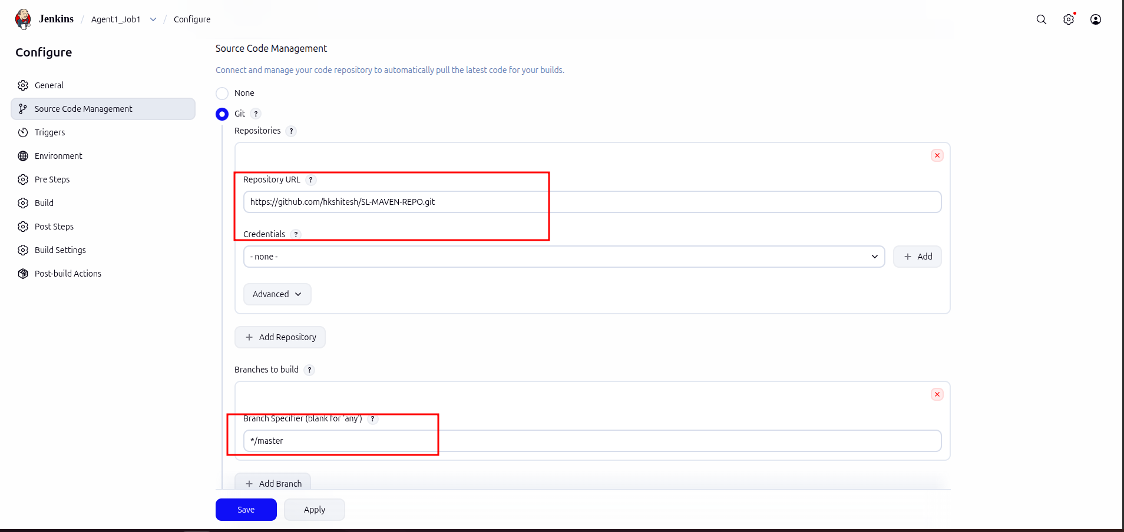
3.3 Click on Restrict where this object can be run → Label Expression as Slave-1

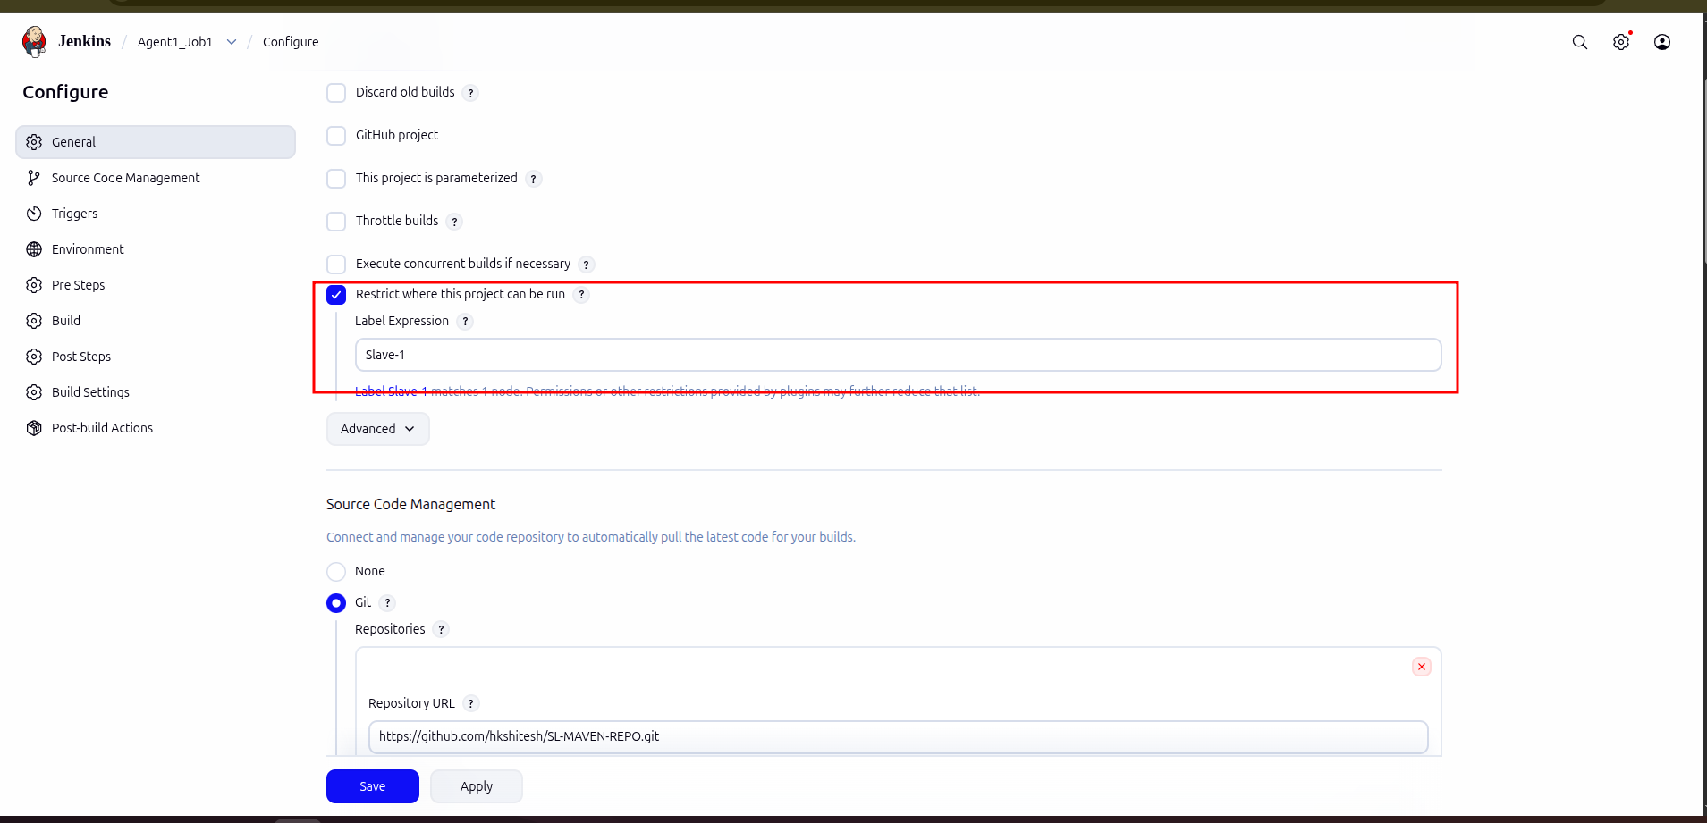

3.4 Do the same steps for Agent2

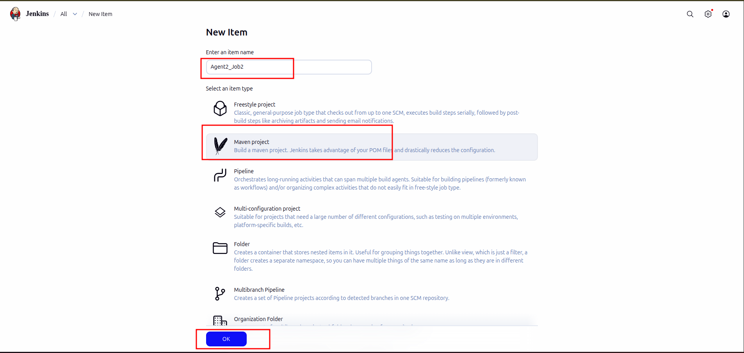

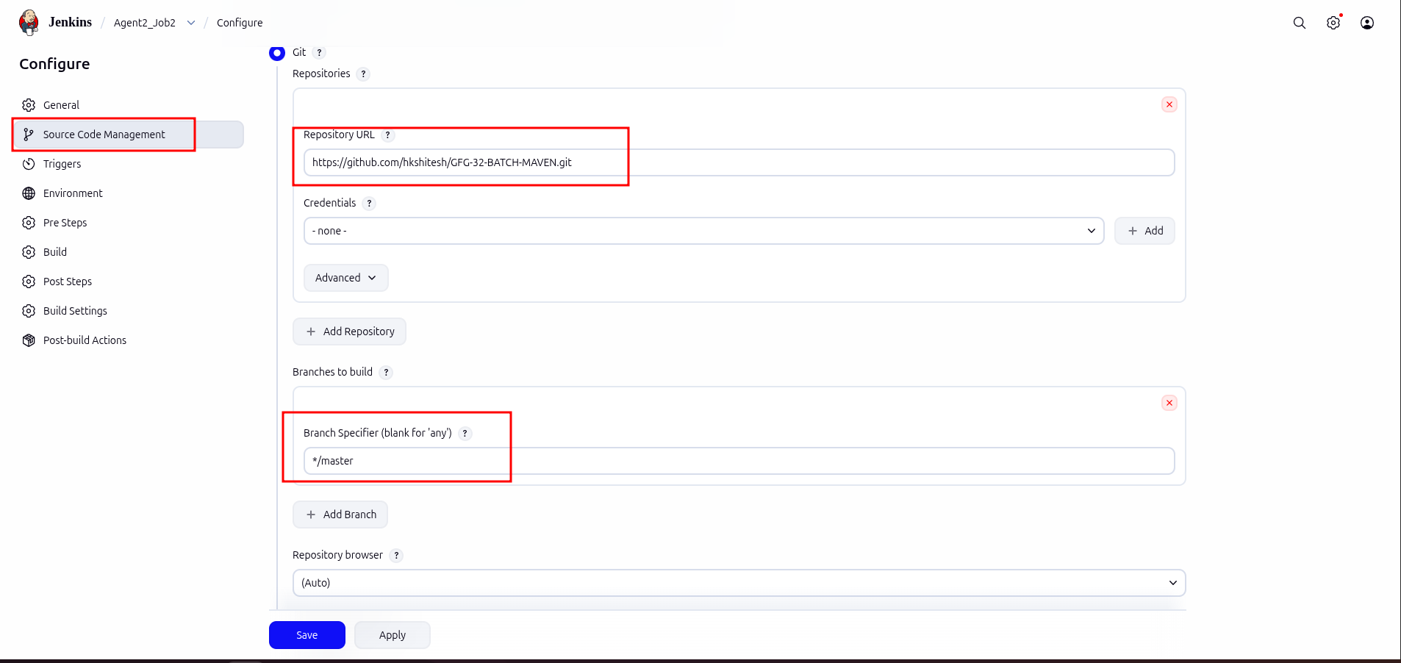

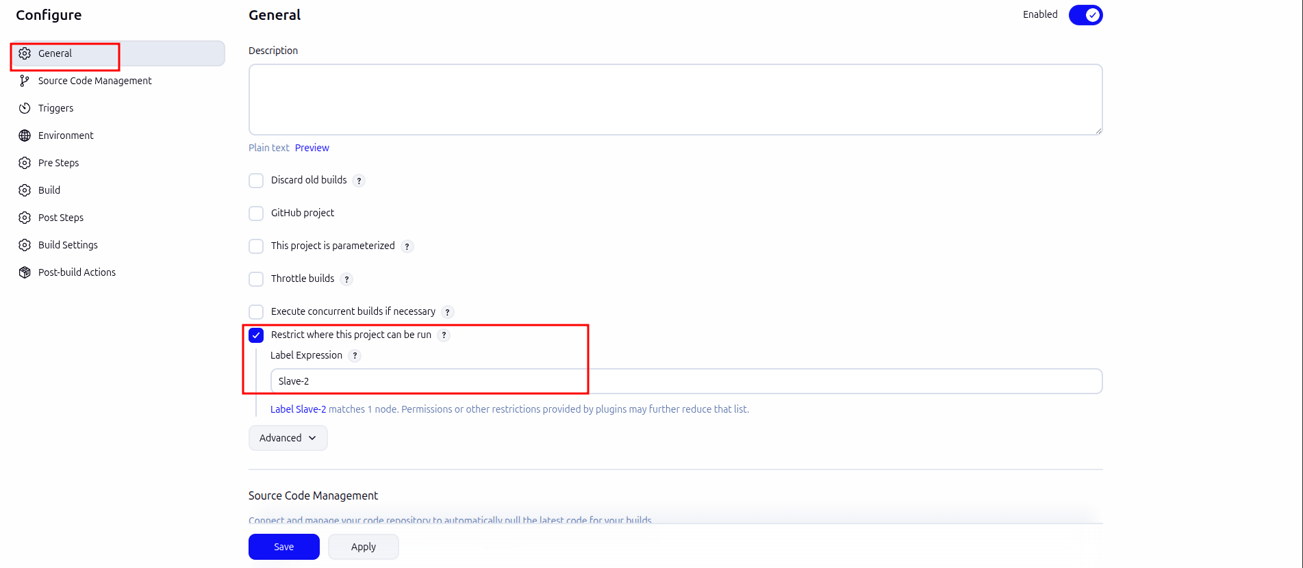

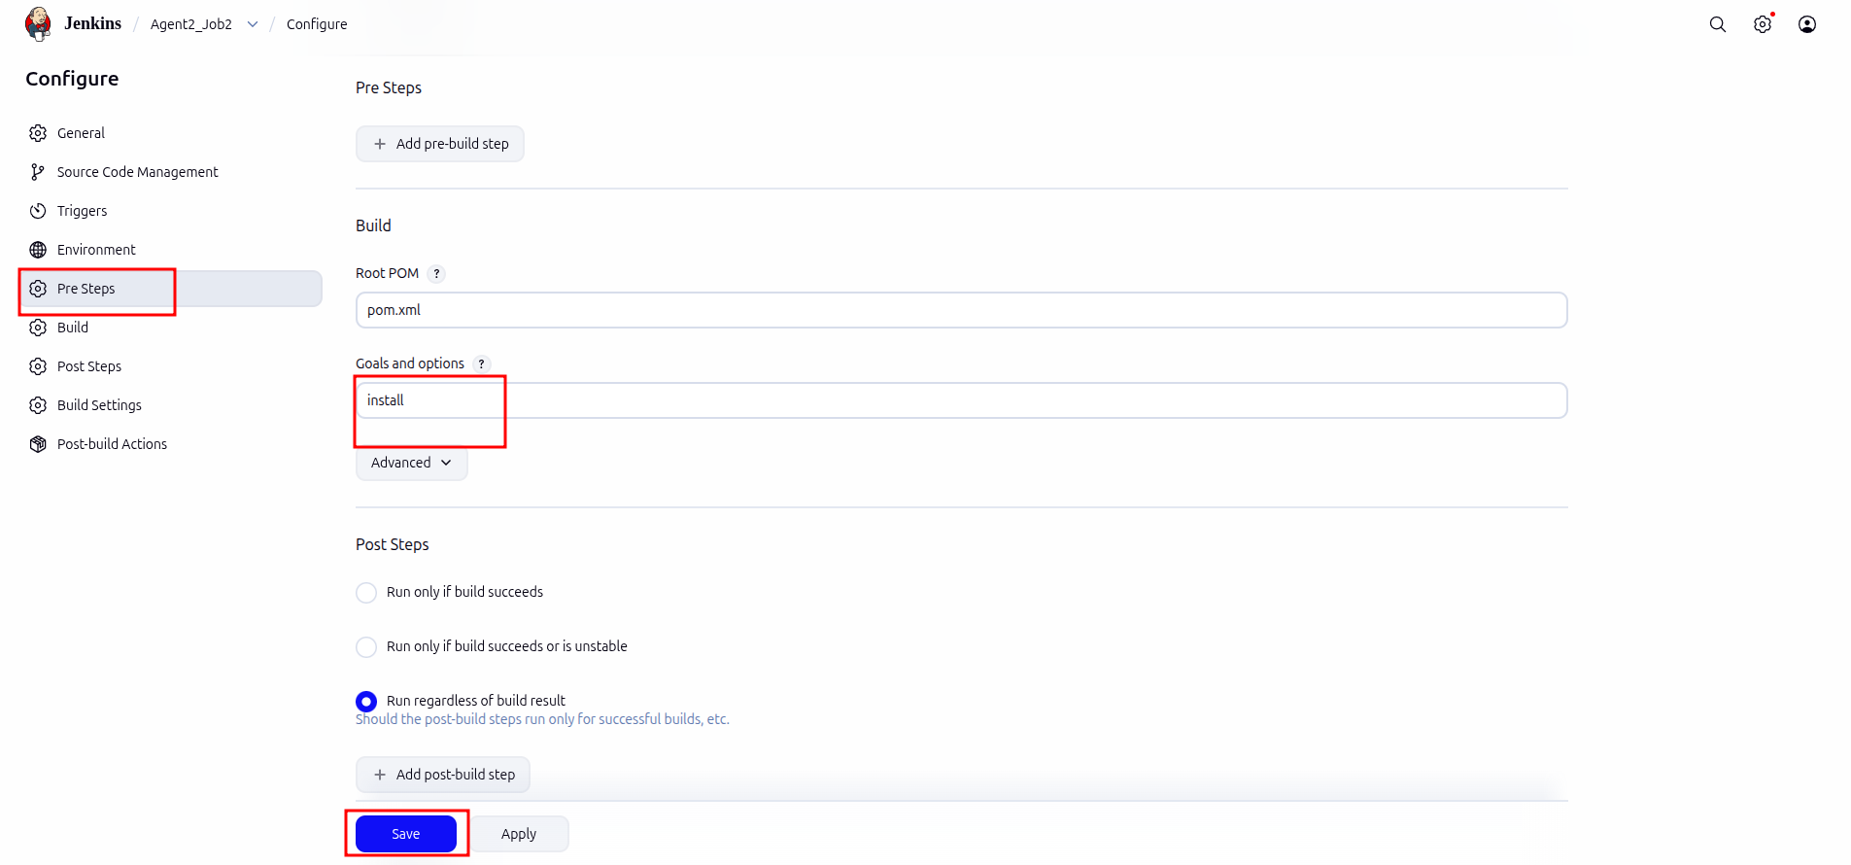

Step 4: Now Build the jobs

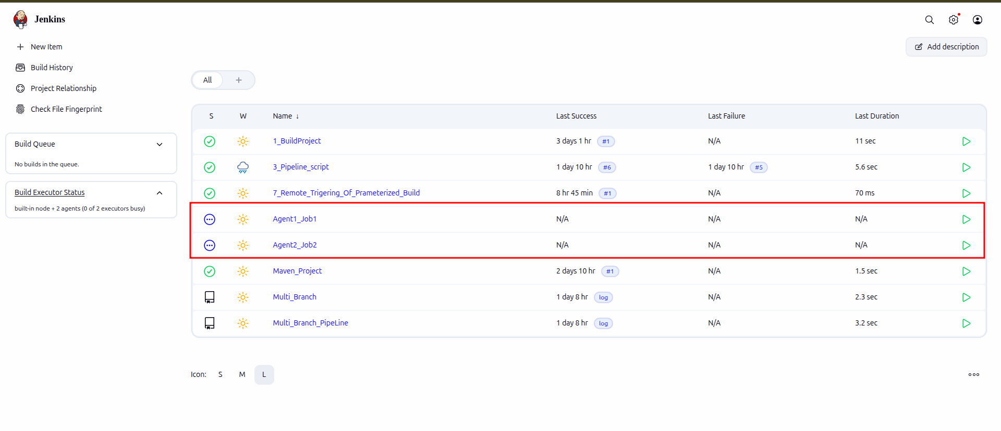
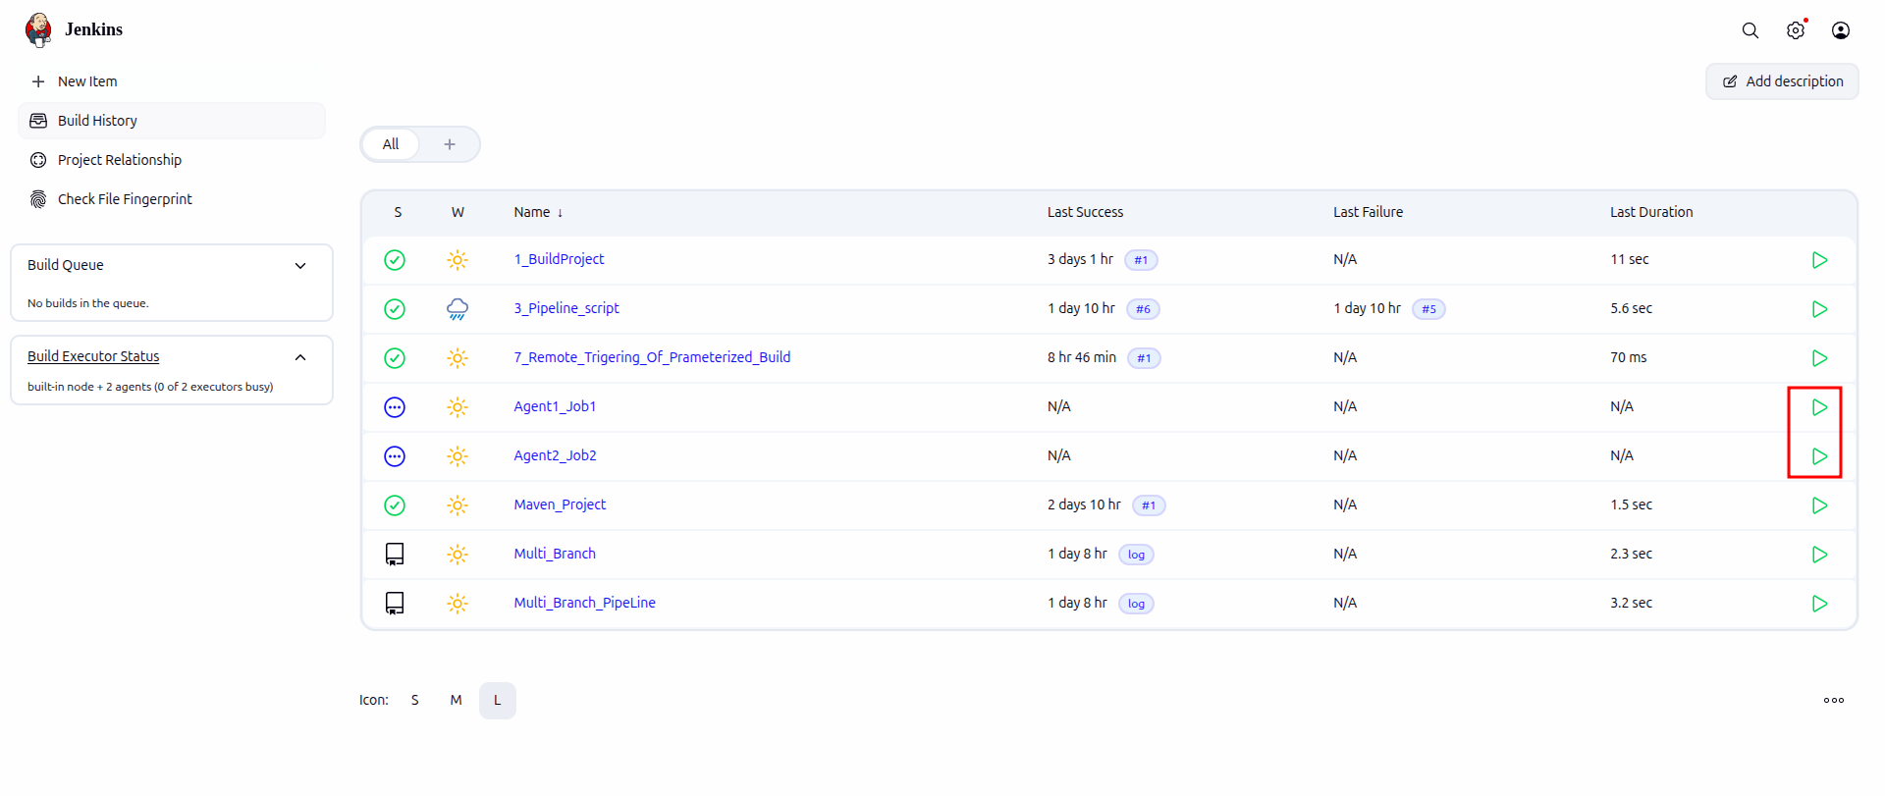

4.1 If the job run fails
4.1.1: Install full JDK in both terminal
sudo apt update
sudo apt install openjdk-17-jdk -y
4.1.2 : Verify Again: ls /usr/lib/jvm/java-17-openjdk-amd64/bin/javac
javac -version
Expected: javac 17...
4.1.3 Go to: Manage Jenkins → Tools → JDK Installations → Add → /usr/lib/jvm/java-17-openjdk-amd64
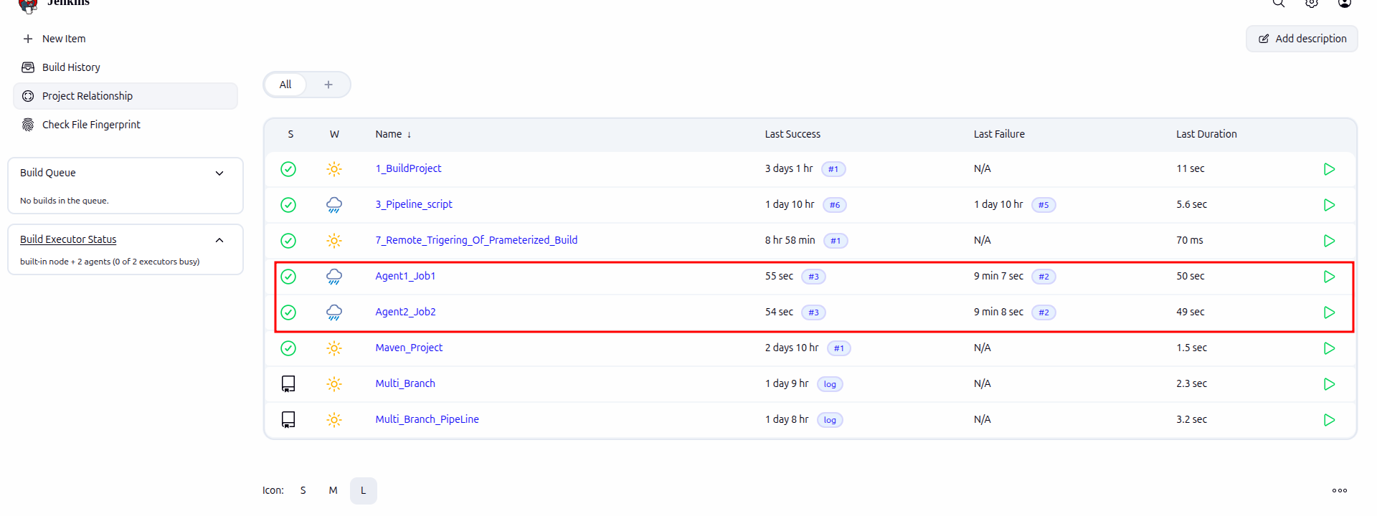

Step 5: Check the Jobs

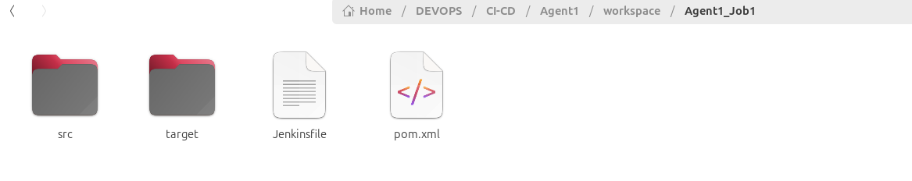

5.1 Go To target folder of Agent1 → ls → run sl-calc.jar

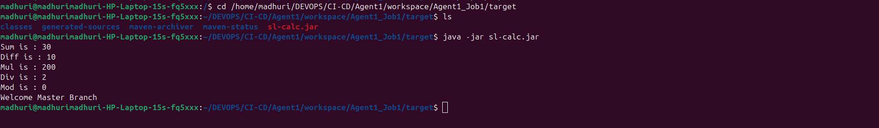

5.2 Similarly do for Agent2

